Coffee Shop Sales Analysis

**Objective:**

The objective of this project is to perform data analysis on Coffee sales in various restaurants in Manhattan City and provide various insights and recommendations to imporove the sales.

**Data Cleaning:**

Data cleaning and preprocessing is done on the dataset to make it comfortable for analysis. Adding columns, extracting day, month, size of coffee preferred, change in data types, etc. are performed.

**Insights into the Data:**

* Morning hours contribute to the maximum sales of the coffee.
* The coffee orders reach the peak at 7 A.M to 10 A.M and as the day progress the sales reduces.
* 39% of the product is dominated by coffee. This gives an idea the people of Manhattan city prefer coffee and its variants as their primary beverage.
* Weekdays like Wednesday, Thursday, Friday has more orders when compared to other days. The reason behind this may be a lot of working section of people prefer to have coffee in these days as stress busters compared to weekends.
* A large section of people prefers large and regular size coffee and also there is a huge section of people whose preference is unknown may be because of the difference between the selling brands.
* These are the top five popular brands associated with the people of Manhattan and also contributes to the maximum revenue generated.
* Lower Manhattan, Hell’s Kitchen, Astoria are the busiest locations and also contributing to the most of the revenue.

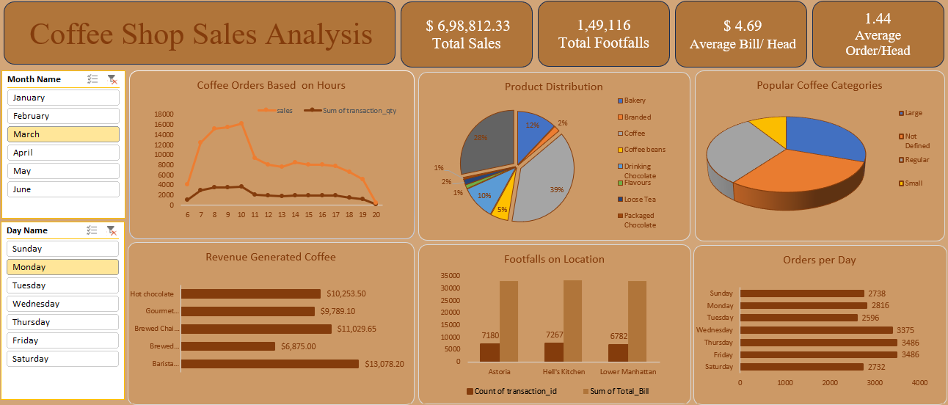

**Conclusion**:

The conclusion of this project is, coffee is one of the most important part of the daily activities. It also has a great contribution in the economy by an average of $4.69 per head. The total footfalls are 149,116 contributing to $698,812.33 in the last six months.